**Step 1: Register an Account**

* **Visit the Registration Page:** Go to [Librarika Registration](https://librarika.com/users/register).
* Fill in Your Details:

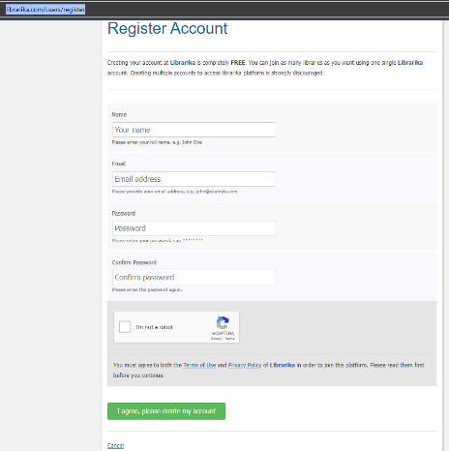

**Step 2: Email Verification**

* Check Your Email:
  1. Look for a verification email from Librarika in your inbox. If you don't see it, check your spam or junk folder.
* Verify Your Account:
  1. Open the email and click on the verification link provided to confirm your account.

**Step 3: Request Member Access**

* **Access 'My Libraries':**
  1. Navigate to the "My Libraries" section from your account dashboard.
* **Request Access:**
  1. Click on "Request Member Access"
  2. Enter the library URL you wish to join (<https://jamali.librarika.com>)

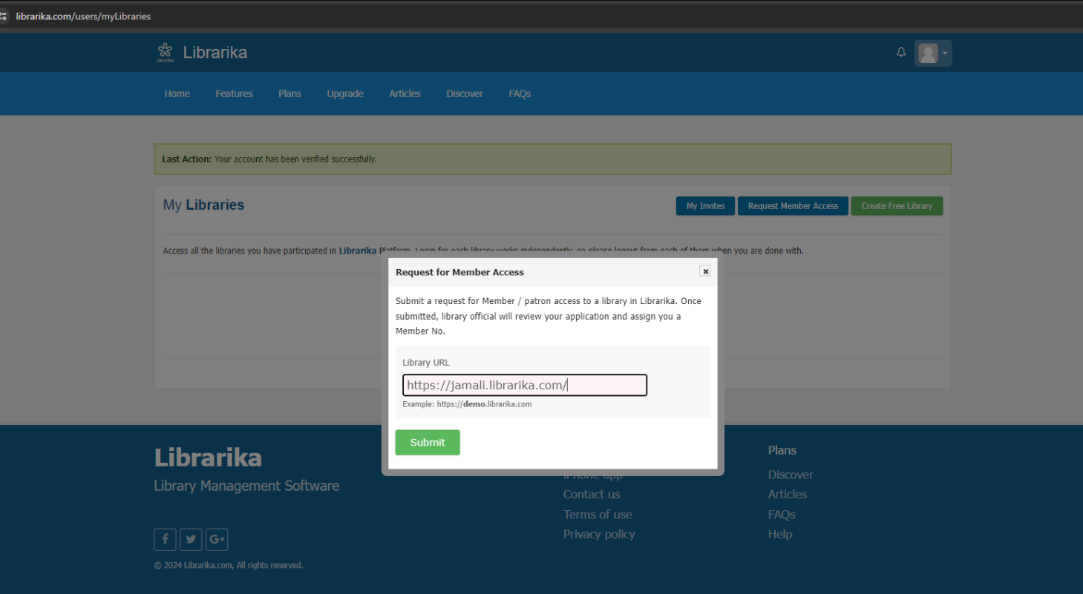

* **Submit Request:**
  1. Click "Submit" to send your request.
* **Confirmation:**
  1. You will see a confirmation message indicating that your request has been successfully submitted and automatically approved.

**Step 5: Access the Library Catalog**

* **Login to the Library:**
  1. Once your member access is approved, login to the library using your credentials.
* **Explore Resources:**
  1. Use the search catalog and library resources to explore and manage your library account.

